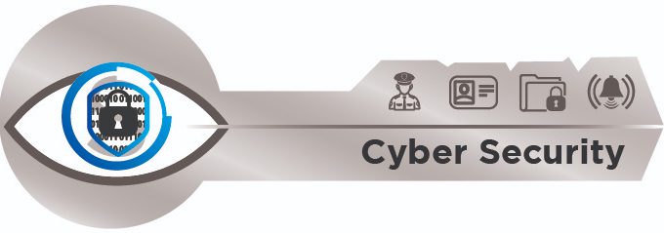
How to report phishing / suspicious emails
- Start a new message and address it to spam@altcloud.ca
- On the Insert tab in the ribbon
- In the Include section
- Click on Outlook Item
- In the Insert Item dialogue box, select the phishing email in the Items: list
- Select Attachment in the Insert as section
- Click on OK and send the email

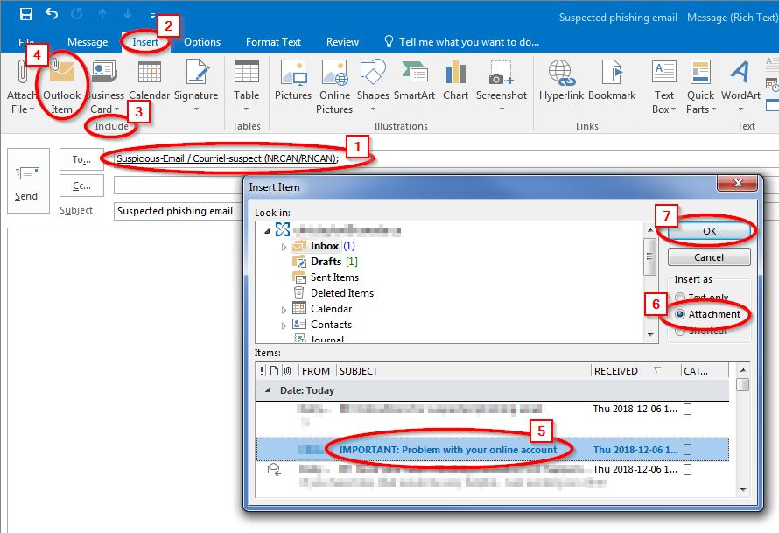

Important Note:

The phishing email sent to spam@altcloud.ca remains in the Inbox. The message needs to be delete.
- In the Inbox, select the phishing email you want to delete.
- Press the Shift + Delete keys at the same time.
- In the pop-up box, as shown below, click the Yes button. (Shift + Delete permanently deletes messages as it bypasses the deleted items folder in Outlook).

