Phishing Basics – Common Signs
Some of the common signs that a message is not from the apparent source and possibly phishing:

- The message has a generic greeting, for example "Dear Customer." Most organizations, including banks and credit and loan organizations, send official correspondence with full names on it. Note: some phishers have moved on to “spear phishing”, which can include personalized information, so it is important to carefully watch for other phishing criteria below.

- Language that threatens an adverse consequence (e.g. deactivated accounts, cancelled cellular subscriptions, legal actions etc.) and some associated request for immediate action, such as "Please reply within five business days or we will cancel your account." Most companies want you as a customer and are not likely to be so quick to lose your business.

- Either the message, or some web page that’s linked from the message, will request personal information. Organizations with which you are already doing business would never ask for personal information by phone or through e-mail even before phishing became a widespread practice.

- Suspicious links in an email (e.g. links that are longer than normal, contain the @ symbol or are misspelled) could be signs of phishing. It is safer to type the business's URL (e.g. typing only the main domain without lengthy path like www.company.com) into your browser than to click on any link sent in e-mail. If there is a reason to communicate with the organization, YOU should initiate the call by using an officially published contact phone number from a website.

- Misspellings and poor grammar in an email purporting to be from a professional corporate source or other official organization (e.g. a government department or other entity). Large reputable organizations have specialized corporate communications functions and rarely make obvious typos.

Here is an example of a Phishing Email that follows the patterns described above:

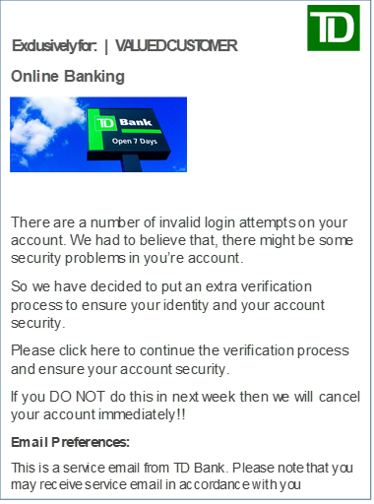
Imperative language demanding immediate action
Request to alter security credentials
More poor grammar and sentences
Distorted graphic and poor grammar
Generalized salutation
Your TD Bank accounts has been locked!

